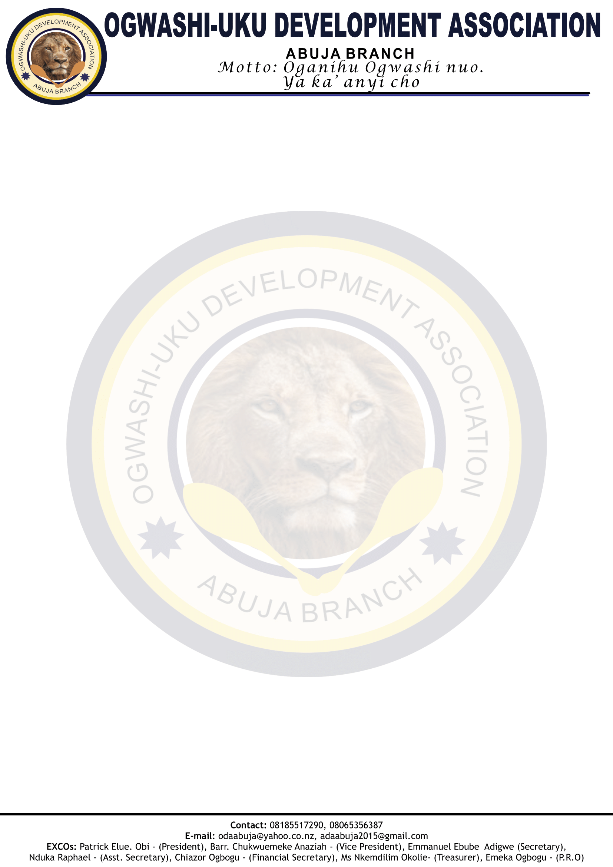

*Date: 23rd October, 2024*

Kenneth Ebube,

**OGWASHI-UKU DEVELOPMENT ASSOCIATION 2024 END-OF-YEAR CELEBRATION: SPECIAL INVITATION AND APPEAL SUPPORT**

It is with pleasure that we invite you as a special guest to 2024 End-of-Year celebrations by the Ogwashi-Uku community in Abuja, Federal Capital Territory (FCT) under the auspices of Ogwashi-Development Association (ODA), Abuja Branch. The event will take place on **Saturday 7th December 2024 at Floris Garden, Wuse Zone 3.**

This is an annual event that brings us together, as sons and daughters of Ogwashi-Uku to celebrate the end of the year in a convivial.

l atmosphere with merriment and display of our unique cultural endowments in thanksgiving to the Almighty God. It is usually financed by the voluntary contributions of sons and daughters of Ogwashi-Uku. This year’s celebration is planned to be a remarkable and memorable occasion.

We recognize you as an illustrious and prominent son of Ogwashi-Uku and will be honoured by your esteemed presence to grace the occasion. In addition, your voluntary financial contribution for the successful organization of the event will be highly appreciated. Kindly send your contributions to the account of **Ogwashi-uku Development Association, Bank: FCMB, Account Number: 2001099617.**

Thank you and God Bless you as we look forward to your graceful presence at the occasion.

Sincerely,

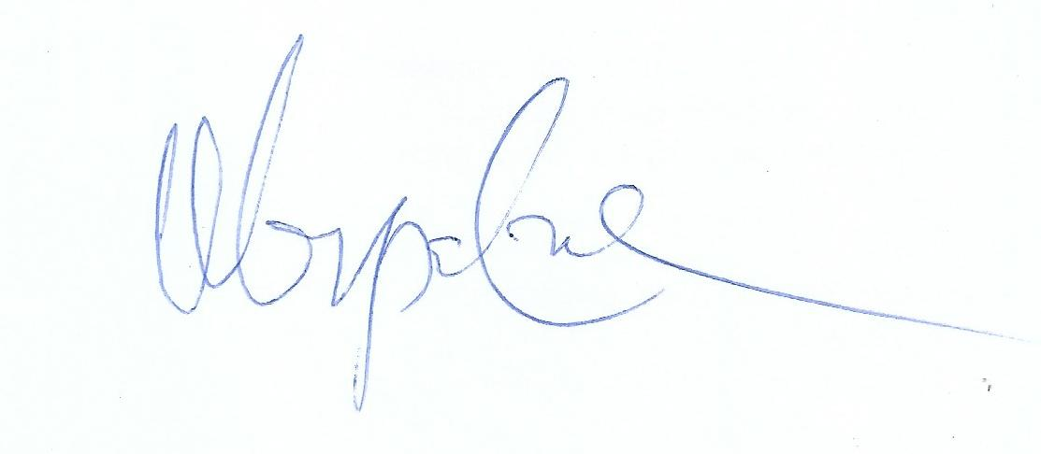

**Pius Chukwuka Elumeze** **Prince Patrick Obi**

*Chairman, President,*

Mobilization and Planning Committee**,** Ogwashi-Uku Development Association,

End-of-Year Celebration. Abuja Branch.